**DAILY ONLINE ACTIVITIES SUMMARY**

|  |  |  |  |  |  |  |  |  |
| --- | --- | --- | --- | --- | --- | --- | --- | --- |
| **Date:** | **04-07-2020** | | | | | **Name:** | **Deril Quadras** | |
| **Sem & Sec** | **8 A** | | | | | **USN:** | **4AL16CS031** | |
| **Online Test Summary** | | | | | | | | |
| **Subject** | | **-** | | | | | | |
| **Max. Marks** | | **-** | | **Score** | | | **-** | |
| **Certification Course Summary** | | | | | | | | |
| **Course** | **Undderstanding CIDR Notation.** | | | | | | | |
| **Certificate Provider** | | | **AWS** | | **Duration** | | | **30 mins** |
| **Coding Challenges** | | | | | | | | |
| **Problem Statement:**   1. **Write a C Program to Add 2 Fractions** | | | | | | | | |
| **Status: Solved** | | | | | | | | |
| **Uploaded the report in Github** | | | | | **Yes** | | | |
| **If yes Repository name** | | | | | **Derilquadras/online_c_coding_repository** | | | |
| **Uploaded the report in slack** | | | | | **Yes** | | | |

Online Test Details:

Not Conducted

Certification Course Details:

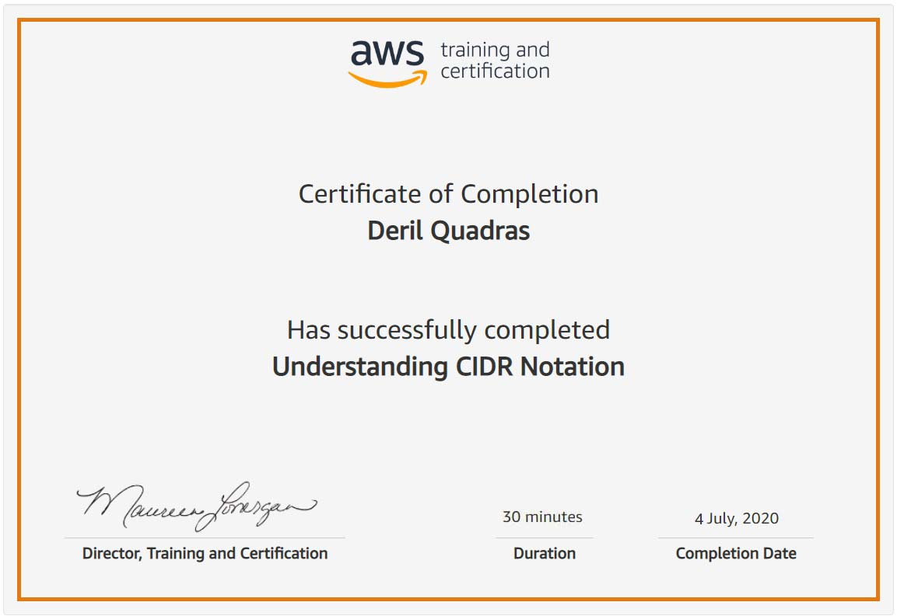

Coding Challenges Details:

**PROGRAM 1 .**

**// Add 2 Fractions**

**#include <stdio.h>**

**int main () {**

**int x1, y1, x2, y2, x3, y3, div, i;**

**printf("Enter the value for x1 and y1(x1/y1):");**

**scanf("%d/%d", &x1, &y1);**

**printf("%d/%d\n",x1,y1);**

**printf("Enter the value for x2 and y2(x2/y2):");**

**scanf("%d/%d", &x2, &y2);**

**printf("%d/%d\n",x2,y2);**

**x3 = (x1 * y2) + (x2 * y1);**

**y3 = (y1 * y2);**

**if (x3 > y3) {**

**div = y3;**

**} else {**

**div = x3;**

**}**

**for (i = div; i > 0; i--) {**

**if (x3 % i == 0 && y3 % i == 0) {**

**x3 = x3 / i;**

**y3 = y3 / i;**

**}**

**}**

**printf("Sum of given two fraction is %d/%d\n", x3, y3);**

**return 0;**

**}**